R-Assignment.R

Jason

2021-01-31

#Data comes from ISLR package that contains pre-made data sets  
  
library(ISLR)  
attach(Auto)  
summary(Auto)

## mpg cylinders displacement horsepower weight   
## Min. : 9.00 Min. :3.000 Min. : 68.0 Min. : 46.0 Min. :1613   
## 1st Qu.:17.00 1st Qu.:4.000 1st Qu.:105.0 1st Qu.: 75.0 1st Qu.:2225   
## Median :22.75 Median :4.000 Median :151.0 Median : 93.5 Median :2804   
## Mean :23.45 Mean :5.472 Mean :194.4 Mean :104.5 Mean :2978   
## 3rd Qu.:29.00 3rd Qu.:8.000 3rd Qu.:275.8 3rd Qu.:126.0 3rd Qu.:3615   
## Max. :46.60 Max. :8.000 Max. :455.0 Max. :230.0 Max. :5140   
##   
## acceleration year origin name   
## Min. : 8.00 Min. :70.00 Min. :1.000 amc matador : 5   
## 1st Qu.:13.78 1st Qu.:73.00 1st Qu.:1.000 ford pinto : 5   
## Median :15.50 Median :76.00 Median :1.000 toyota corolla : 5   
## Mean :15.54 Mean :75.98 Mean :1.577 amc gremlin : 4   
## 3rd Qu.:17.02 3rd Qu.:79.00 3rd Qu.:2.000 amc hornet : 4   
## Max. :24.80 Max. :82.00 Max. :3.000 chevrolet chevette: 4   
## (Other) :365

Avgmpg <-mean(mpg)  
plot(cylinders, mpg, type = "p")

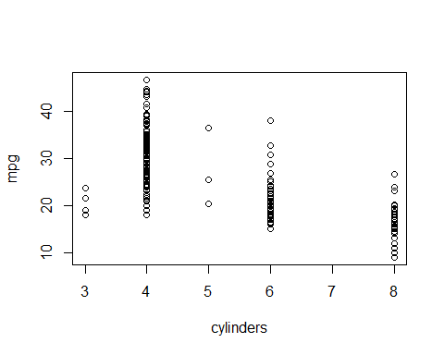

plot(cylinders, acceleration, type = "p")

